**Review Paper**

**Diet Recommendation System Using Machine Learning**

Aishwarya Srivastava, Anushka Thapliyal, Ayush Singh, Utkarsh Upadhyay

Student, Dept. of Computer Science & Engineering (Data Science)

Ms. Tanya

Asso. Prof. Dept. of Computer Science & Engineering (Data Science)

**Abstract :** The human body needs nutrients, vitamins and minerals to prevent disease. When the body does not receive adequate nutrients, nutritional deficiencies can arise and cause a number of different health issues. Nutritional issues including dietary excesses or deficits in certain nutrients can lead to chronic illnesses such as diabetes, hypertension, and cardiovascular disease. Deficiencies can affect the heart and cause damage to muscles and neurons. You must therefore eat a healthy diet. A balanced diet provides your body with the nutrition it needs to operate correctly. This project provides the foundation for providing users with suitable nutrition plans. It is a disease-based nutritional guidance system that makes dietary recommendations based on the needs of the product by utilizing information about the user's health. Our approach has the potential to be a helpful tool for both improving nutrition and helping people maintain and improve their health condition. This research work is carried out using Machine learning.

**Introduction**

In the contemporary world, people are becoming more conscious of their lifestyle and health. However, a balanced diet and exercise by themselves won't cut it; we also need to avoid junk food. Eating a balanced diet appropriate for our age, weight, and height can help us live a healthy life. Together with exercise, a balanced diet can help you reach and maintain a healthy weight, reduce your risk of chronic conditions like cancer and heart disease, and enhance your overall health.

The choices from the options we make about what we are consuming in our diet have a profound impact on our physical well-being and health. In an era of increasing awareness of the importance of a healthy diet, diet recommendation systems have emerged as a promising tool to provide personalized dietary guidance. These systems combine the power of technology, data science, and artificial intelligence to offer individuals tailored advice on their food choices, meal planning, and nutritional needs.

The significance of diet recommendation systems lies not only in their ability to guide individuals towards healthier eating habits but also in their potential to address specific dietary restrictions and health conditions. With the exponential growth of dietary data sources, such as food databases, nutritional information, and user-generated data, these systems can analyse a vast array of dietary preferences and requirements to provide recommendations that are highly personalized.

Personalized dietary guidance is a departure from the one-size-fits-all approach that has traditionally been the norm. It takes into account individual factors such as age, gender, activity level, dietary preferences, and even genetic predispositions. By doing so, diet recommendation systems have the potential to improve the dietary choices of individuals and, in turn, contribute to the prevention and management of diet-related diseases.

This review paper aims to provide an in-depth exploration of the state of the art in diet recommendation systems. We will delve into the algorithms that power these systems, the various applications they serve, the data sources they rely on, and the challenges they face. Additionally, we will examine the potential impact of diet recommendation systems on public health and wellness.

**Literature Review**

Common Health issues

Dahiwade et al. suggested an ML-based method for common disease prediction [9]. The UCI ML library was used to import the symptoms dataset, which contained symptoms of several common disorders. The system used CNN and KNN as classification algorithms to forecast several diseases. Further information on the lifestyle of the tested patient was also added to the recommended treatment, which improved the recommendation and helped assess the level of risk related to the expected sickness. Dahiwade et al. [9] examined the KNN and CNN algorithms' accuracy and processing times.

Diseases related to the kidney

In order to identify chronic kidney disease (CKD), Serek et al. [7] created a comparison analysis of classifier performance using the Kidney Function Test (KFT) dataset. In this work, the performance of the KNN, NB, and RF classifiers is assessed using the F-measure, accuracy, and precision. The analysis revealed that NB produced better precision whereas RF received greater accuracy and F-measure scores.

Diseases related to Heart

The aim of Marimuthu et al. [8] was to predict heart diseases by using supervised machine learning techniques. The authors arranged the data elements according to gender, age, target, slope, gender, and chest pain [6]. The following four useful machine learning techniques were applied: DT, KNN, LR, and NB. After analysis, it was found that the LR algorithm provided the highest accuracy of 86.89%, outperforming the other algorithms in terms of efficiency.

Parkinson’s Disease

Chen et al. [4] provided a helpful approach for diagnosing Parkinson's disease (PD) that makes use of fuzzy k-nearest neighbour (FKNN). The primary points of comparison for the study were the suggested FKNN-based and SVM-based methods. Principal Component Analysis (PCA) was used to group the most distinct features for creating the optimal FKNN model. The dataset, which contained a variety of biological voice measures, was retrieved from the UCI depository.

from 31 people, 24 with PD.

**An Overview on Machine Learning**

The process of building analytical models is automated by a data analysis technique known as machine learning. The underlying premise of this branch of artificial intelligence is that robots can learn from data, identify patterns, and form opinions with minimal assistance from humans. The Scikit-learn, or Sklearn, library for Python machine learning is the most dependable and useful. It provides a variety of useful tools for statistical modelling and machine learning, including dimensional reduction, regression, clustering, and classification, through a standardized Python interface. This library is primarily written in Python and is based on NumPy, SciPy, and Matplotlib.

The architecture of disease-based diet prediction system include the listed following fields:

**User Input :** We are using the disease list provided by the user of the diet advice system as input. Obtain info Here, the user will enter information regarding their symptoms.

**Data Acquisition and Processing :** The input for processing is given in this area. First, the data is acquired, and then it is processed. These two processes are known as data acquisition and processing.

**Input Symptoms of the Body :** Body symptoms are collected and analyzed in this field, so that the algorithm may utilize this data to anticipate a potential diet based on the input.

**Dataset_Disease (symptoms, functions) :** Within this domain, there exists a pre-established dataset of illnesses, encompassing both symptoms and functions associated with the condition..

**Training_Data () :** The system is being trained in this field. The SVM (support vector machine) algorithm is used to train our diet advice system. Here, we are solving a regression-related problem with the SVM algorithm.

**Prev_Disease (Dataset_Disease) :** A dataset of diseases is provided in this field as a parameter, and processing is carried out using this dataset.

**Predicting_Multi Linear_Regression (symptoms, function) :** In this stage, the process of prediction is carried out with the help of the MLR algorithm. In MLR algorithm , multiple independent variables are used for the disease prediction.

**Possible_Diet (calorie, function) :** In this stage calorie and functions are passed as a parameter and potential diet is computed based on these inputs.

**Processing of Data:** This sector consist of the above mentioned data processing arenas and is the most important part of our disease prediction system. It comprises of all the essential fields for processing the data.

**Output :** After acquisition of data and data processing, final output diet is generated as result.

**FLOWCHART**

The data set comprises of gender, symptoms, and age of an individual was pre-processed and fed as an input to different ML algorithms for the prediction of the disease. The different ML models used were Fine, Medium and Coarse Decision trees, Gaussian Naïve Bayes, Kernel Naïve Bayes, Fine, Medium and Coarse KNN, Weighted KNN, Subspace KNN, and RUS Boosted trees. The outcome of the models is the disease as per the symptoms, age, and gender is given to the processing model.

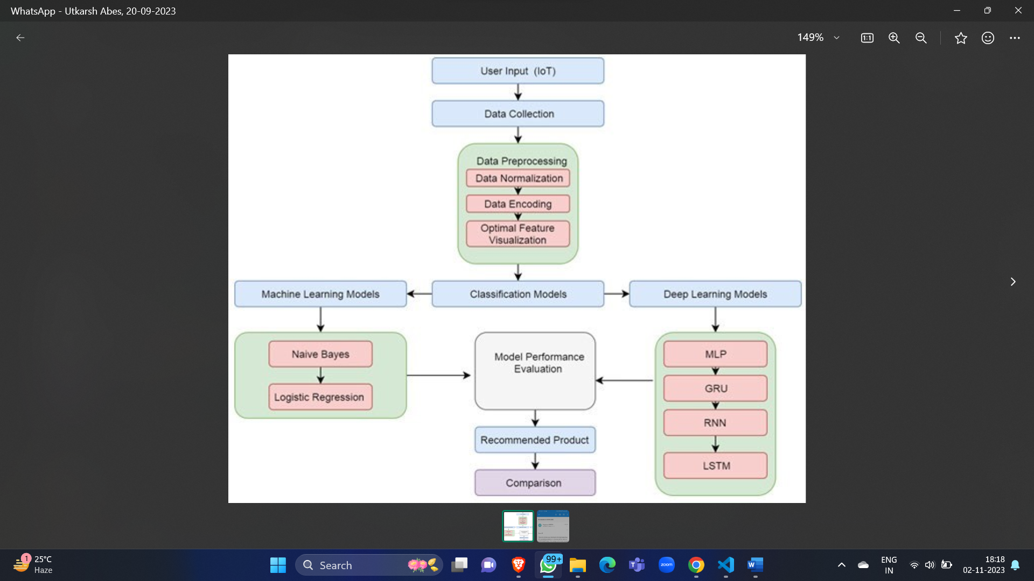

**Fig.1 : Flowchart Diagram of the Project**

**Conclusion**

Diet recommendation systems represent a promising intersection of technology, data science, and healthcare that aims to transform the way individuals approach their dietary choices. This review has shed light on the key aspects of diet recommendation systems, encompassing data sources, recommendation algorithms, applications, user interfaces, challenges, and their potential impact on public health.

The importance of data in powering diet recommendation systems cannot be overstated. These systems draw from diverse sources, including comprehensive food databases, nutritional information, and user-generated data, while also capitalizing on wearable devices and IoT sensors to provide real-time, personalized insights. Machine learning algorithms, like as content-based filtering, collaborative filtering and advanced neural networks, enable the delivery of tailored dietary guidance to users. The adaptability of these algorithms to individual preferences and dietary restrictions holds great promise for promoting healthier food eating habits.

Diet recommendation systems find applications in various arenas, from personalized meal planning and recipe suggestions to weight management and dietary restriction support. They are particularly valuable for individuals managing health conditions, as they can provide condition-specific dietary recommendations. These systems have the potential to revolutionize the way we address diet-related diseases and conditions by offering precise, data-driven advice.

User interfaces and engagement strategies are pivotal in ensuring that individuals receive and act upon these recommendations effectively. Mobile apps, web platforms, and voice assistants provide accessible and user-friendly interfaces. Gamification and behavioral nudging strategies enhance user engagement and adherence to dietary guidance, making it more likely that individuals will make healthier food choices.

However, diet recommendation systems face several challenges and limitations, including privacy concerns related to dietary data, the need to respect cultural and individual dietary preferences, and ethical considerations that arise from potential biases in recommendations. Addressing these challenges is crucial for the continued development and adoption of these systems.

In terms of public health impact, diet recommendation systems hold the potential to significantly reduce the burden of diet-related diseases and associated healthcare costs. By providing individuals with personalized dietary guidance and empowering them to make informed choices, these systems may contribute to improved overall health and well-being.

In conclusion, diet recommendation systems are supposed to play a crucial role in the future of dietary guidance. Leveraging the power of AI and data science, these systems offer individuals the tools they need to make healthier food choices, tailored to their specific needs and preferences. As the field continues to evolve, further research and innovation will be essential to address challenges, mitigate biases, and maximize the potential for positive public health outcomes.

**References**

[1] T. N. Trang Tran, M. Atas, A. Felfernig, and M. Stettinger, ‘‘An overview of recommender systems in the healthy food domain,’’ J. Intell. Inf. Syst., vol. 50, no. 3, pp. 501–526, Jun. 2018.

[2] C. Chensi, L. Feng, T. Hai, S. Deshou, S. Wenjie, L. Weizhong, Z. Yiming, B. Xiaochen, and X. Zhi, ‘‘Deep learning and its applications in biomedicine,’’ Genomics Proteomics Bioinf., vol. 16, no. 1, pp. 17–32, 2018.

[3] S. Saini and S. K. Dubey, ‘‘Recommendation of diet to jaundice patient on the basis of nutrients using AHP and fuzzy AHP technique,’’ Int. J. Intell. Eng. Syst., vol. 10, no. 4, pp. 91– 99, Jul. 2017, doi: 10.22266/ ijies2017.0831.10.

[4] L. Yang, C.-K. Hsieh, H. Yang, J. P. Pollak, N. Dell, S. Belongie, C. Cole, and D. Estrin, ‘‘Yum-Me: A personalized nutrient-based meal recommender system,’’ ACM Trans. Inf. Syst., vol. 36, no. 1, pp. 1–31, Jul. 2017.

[5] J. Mariapun, C.-W. Ng, and N. N. Hairi, ‘‘The gradual shift of overweight, obesity, and abdominal obesity towards the poor in a multi-ethnic develop ing country: Findings from the Malaysian National health and morbidity surveys,’’ J. Epidemiol., vol. 28, no. 6, pp. 279–286, Jun. 2018.

[6] A. Kale and N. Auti, ‘‘Automated menu planning algorithm for children: Food recommendation by dietary management system using ID3 for Indian food database,’’ Procedia Comput. Sci., vol. 50, pp. 197–202, Jan. 2015.

[7] H. Schäfer, M. Elahi, D. Elsweiler, G. Groh, M. Harvey, B. Ludwig, F. Ricci, and A. Said, ‘‘User nutrition modelling and recommendation: Balancing simplicity and complexity,’’ in Proc. Adjunct Publication 25th Conf. User Modeling, Adapt. Pers. (UMAP), 2017, pp. 9–12.

[8] H. Dinçer, S. Yüksel, and L. Martínez, ‘‘Balanced scorecard-based analy sis about European energy investment policies: A hybrid hesitant fuzzy decision-making approach with Quality Function Deployment,’’ Expert Syst. Appl., vol. 115, pp. 152–171, Jan. 2019.

[9] F. Rehman, O. Khalid, N. Haq, A. R. Khan, and K. B. Sajjad, ‘‘Diet-right: A smart food recommendation system,’’ KSII Trans. Internet Inf. Syst., vol. 11, no. 6, Jun. 29, 2017, doi: 10.3837/tiis.2017.06.006.

[10] C. Iwendi, Z. Zhang, and X. Du, ‘‘ACO based key management rout ing mechanism for WSN security and data collection,’’ in Proc. IEEE Int. Conf. Ind. Technol.(ICIT), Lyon, France, Feb. 2018, pp. 1935–1939, doi: 10.1109/icit.2018.8352482.

[11] S. Norouzi, A. K. Ghalibaf, and S. Sistani, ‘‘A mobile application for managing diabetic patients’ nutrition: A food recommender system,’’ Arch. Iranian Med., vol. 21, no. 10, pp. 466– 472, 2018.